ENGINEERING OPTIMIZATION ASSIGNMENT
Three engineering design problems solved using six MATLAB optimization algorithms
Algorithms: Genetic Algorithm (ga), Sequential Quadratic Programming via fmincon, Pattern Search, Surrogate Optimization, Simulated Annealing, and Particle Swarm Optimization.

PART A: EXAM-STYLE QUESTIONS AND MATHEMATICAL FORMULATIONS
Mathematical formulation, constraints, MATLAB implementation and plots

Algorithms to be used
Use all six algorithms for each question: ga, fmincon, patternsearch, surrogateopt, simulannealbnd, and particleswarm. The supplied MATLAB runner applies the same penalized objective and variable bounds to all six methods, repeats each method three times, and reports the median elapsed time.

Important MATLAB requirements
Install or obtain access to Optimization Toolbox (for fmincon) and Global Optimization Toolbox (for ga, patternsearch, surrogateopt, simulannealbnd, and particleswarm). In MATLAB, type ver to inspect installed products.
Place all four .m files in the same Current Folder. Run Question1_Foundation, Question2_Beam, and Question3_WaterTank separately. Each question produces a results CSV, a time-comparison graph, an objective-comparison graph, and a design-space plot.
The design-space plots are mathematical objective/feasibility plots. The solver comparison plots are generated by MATLAB from the actual execution times and objective values on the computer where the scripts are run. Do not report invented timing results.

QUESTION 1: ISOLATED RECTANGULAR FOOTING
problem statement:
A centrally loaded column transmits a vertical load of 1,800 kN to a rectangular isolated footing founded on soil. The footing length is to be 1.2 times its width. The allowable soil bearing pressure is 200 kN/m². The soil has an elastic modulus of 20,000 kN/m² and Poisson's ratio of 0.30. Use a settlement influence factor of 1.12 and an allowable immediate settlement of 25 mm. The footing width is restricted to 2.5–5.0 m and its thickness is restricted to 0.45–0.80 m. Formulate the problem to minimize the volume of concrete while satisfying the bearing-pressure and settlement requirements. Solve using the six specified MATLAB algorithms and compare their results and computation times.

Design variables
B = footing width (m); D = footing thickness (m); L = 1.2B.

Objective function
Minimize f(B,D) = BLD = 1.2B²D.

Constraints
Bearing pressure: q = P/(BL) = 1800/(1.2B²) ≤ 200 kN/m².
Settlement estimate: s = qB(1 − ν²)If/Es ≤ 0.025 m.
Bounds: 2.5 ≤ B ≤ 5.0 m; 0.45 ≤ D ≤ 0.80 m.
Normalized inequalities for the MATLAB penalty function: g1 = q/qa − 1 ≤ 0; g2 = s/sAllow − 1 ≤ 0.
Expected check: the simplified model gives B approximately 3.06 m, L approximately 3.67 m, D = 0.45 m and concrete volume approximately 5.05 m³. This is a mathematical benchmark only, not a complete footing design.
MATLAB file: Question1_Foundation.m. Shared solver file: runSixSolvers.m.

QUESTION 2: SIMPLY SUPPORTED RECTANGULAR BEAM
problem statement:
A simply supported rectangular beam of span 8 m carries a central point load of 200 kN. The beam is made from a material with Young's modulus 200 GPa. The allowable bending stress is 150 MPa, and the maximum permitted midspan deflection is L/360. The beam width may vary from 0.03 m to 0.15 m, while its depth may vary from 0.25 m to 0.70 m. Formulate an optimization problem to minimize the volume of beam material while satisfying the bending-stress and deflection requirements. Solve using the six specified MATLAB algorithms and compare the optimal dimensions and computation times.

Design variables
b = beam width (m); h = beam depth (m); L = 8 m.

Objective function
Minimize f(b,h) = Lbh = 8bh.

Constraints
Maximum bending moment: Mmax = PL/4.
Second moment of area: I = bh³/12.
Bending stress: σmax = 6Mmax/(bh²) ≤ 150,000 kN/m².
Midspan deflection: δmax = PL³/(48EI) ≤ L/360.
Bounds: 0.03 ≤ b ≤ 0.15 m; 0.25 ≤ h ≤ 0.70 m.
Normalized inequalities: g1 = σmax/σallow − 1 ≤ 0; g2 = δmax/δallow − 1 ≤ 0.
Expected check: with the stated simplified assumptions, the minimum-volume design is near h = 0.70 m and b = 0.03265 m, with volume approximately 0.183 m³. Confirm the exact result and constraint values using MATLAB.
MATLAB file: Question2_Beam.m. Shared solver file: runSixSolvers.m.

QUESTION 3: CLOSED CYLINDRICAL WATER TANK
problem statement:
A closed cylindrical tank is required to store 100 m³ of water. The tank consists of a cylindrical wall, a circular top and a circular bottom. The tank radius must be between 2 m and 4 m, and the tank height must be between 2 m and 10 m. Formulate an optimization problem to minimize the total external surface area of the tank while maintaining the required storage capacity. Solve using the six specified MATLAB algorithms and compare the optimal dimensions and computation times.

Design variables
r = internal tank radius (m); h = internal tank height (m).

Objective function
Minimize A(r,h) = 2πrh + 2πr².

Constraint and bounds
Required volume: πr²h = 100 m³.
Bounds: 2 ≤ r ≤ 4 m; 2 ≤ h ≤ 10 m.

Reduced formulation
Use the equality to eliminate h: h = 100/(πr²). Therefore minimize A(r) = 200/r + 2πr². The feasible radius interval is obtained by applying both the radius and height bounds.
Analytical check: r = (50/π)^(1/3) ≈ 2.515 m; h ≈ 5.031 m; minimum surface area ≈ 119.27 m².
MATLAB file: Question3_WaterTank.m. Shared solver file: runSixSolvers.m.

How to run the codes
Download all four MATLAB .m files.
Put all four files in one folder.
Open MATLAB and set that folder as the Current Folder.
Type ver and check for Optimization Toolbox and Global Optimization Toolbox.
Run Question1_Foundation and wait for its results and figures.
Run Question2_Beam and wait for its results and figures.
Run Question3_WaterTank and wait for its results and figures.
Open the CSV files to see the numerical values, median times and constraint violations.
Use the PNG plots generated by MATLAB in your assignment or presentation.

How to interpret the comparison
The fastest algorithm is the one with the smallest median elapsed time. The best design is the feasible result with the smallest objective value. A low objective value is not acceptable if the constraints are violated. Report both computation time and maximum constraint violation. Since population-based and stochastic algorithms can vary between runs, the code performs three repetitions and reports the median time.
The time-comparison plots are machine-dependent and should be generated on the actual MATLAB computer. The included MATLAB scripts automatically create these plots; the static model plots supplied with the package illustrate the mathematical objective and feasible region, not measured solver performance.

PART B: MATLAB RESULTS
The tables below combine the foundation CSV uploaded in the chat with the beam and tank tables pasted from MATLAB. Computation times are the measured median times reported by the user's MATLAB runs. Times can vary with computer and MATLAB environment.

Question 1: Foundation
Algorithm | Median time (s) | Objective (m³) | Max constraint violation | Exit flag
ga | 0.33462 | 5.0434871 | 0.000493 | 0
fmincon | 0.102453 | 5.04333219 | 0.000504 | 2
patternsearch | 0.106196 | 5.04334049 | 0.000504 | 1
surrogateopt | 57.8308 | 5.04487647 | 0.000459 | 0
simulannealbnd | 0.206153 | 5.04334527 | 0.000503 | 0
particleswarm | 0.0506734 | 5.04332985 | 0.000504 | 1
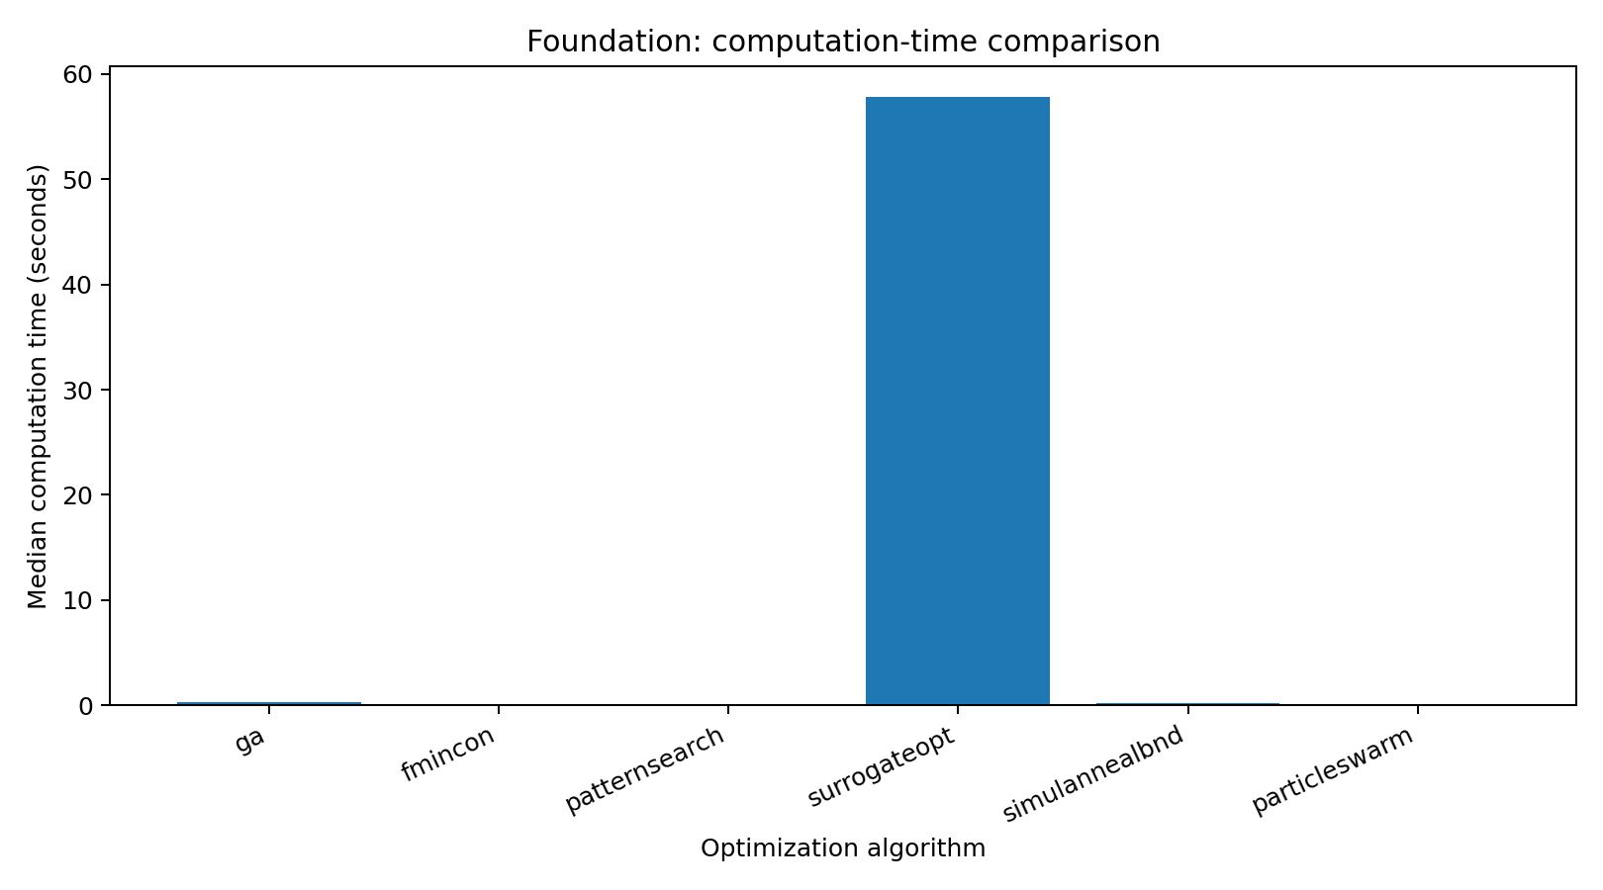
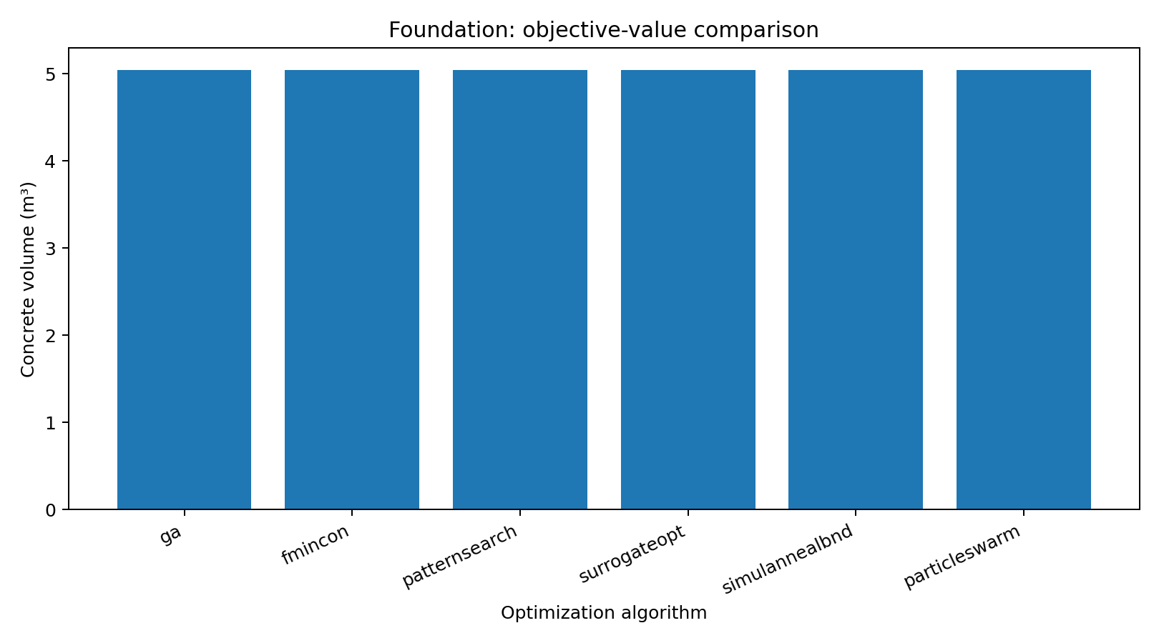

Question 2: Beam
Algorithm | Median time (s) | Objective (m³) | Max constraint violation | Exit flag
ga | 0.404921 | 0.190091442 | 0 | 1
fmincon | 0.0765318 | 0.18285542 | 9.42e-06 | 2
patternsearch | 0.581195 | 0.255884168 | 1.02e-05 | 0
surrogateopt | 56.2328 | 0.186781493 | 0 | 0
simulannealbnd | 0.231304 | 0.187536561 | 0 | 0
particleswarm | 0.138814 | 0.182855471 | 9.14e-06 | 1
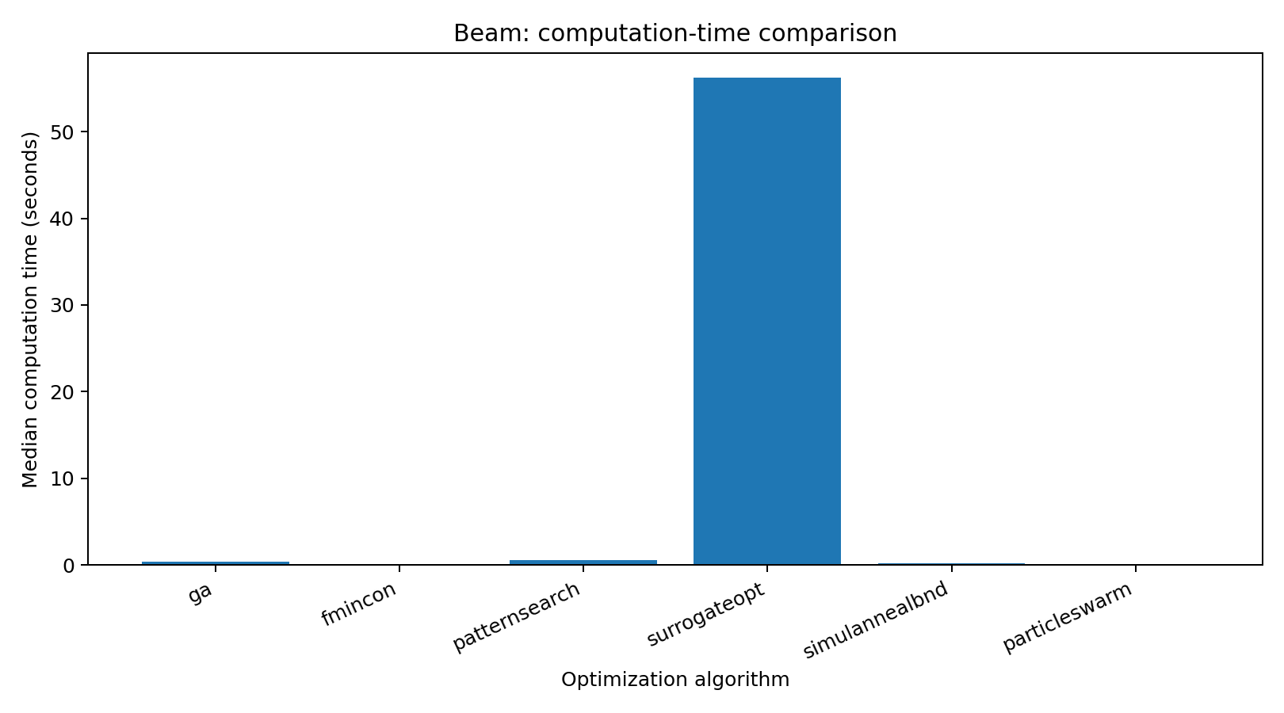
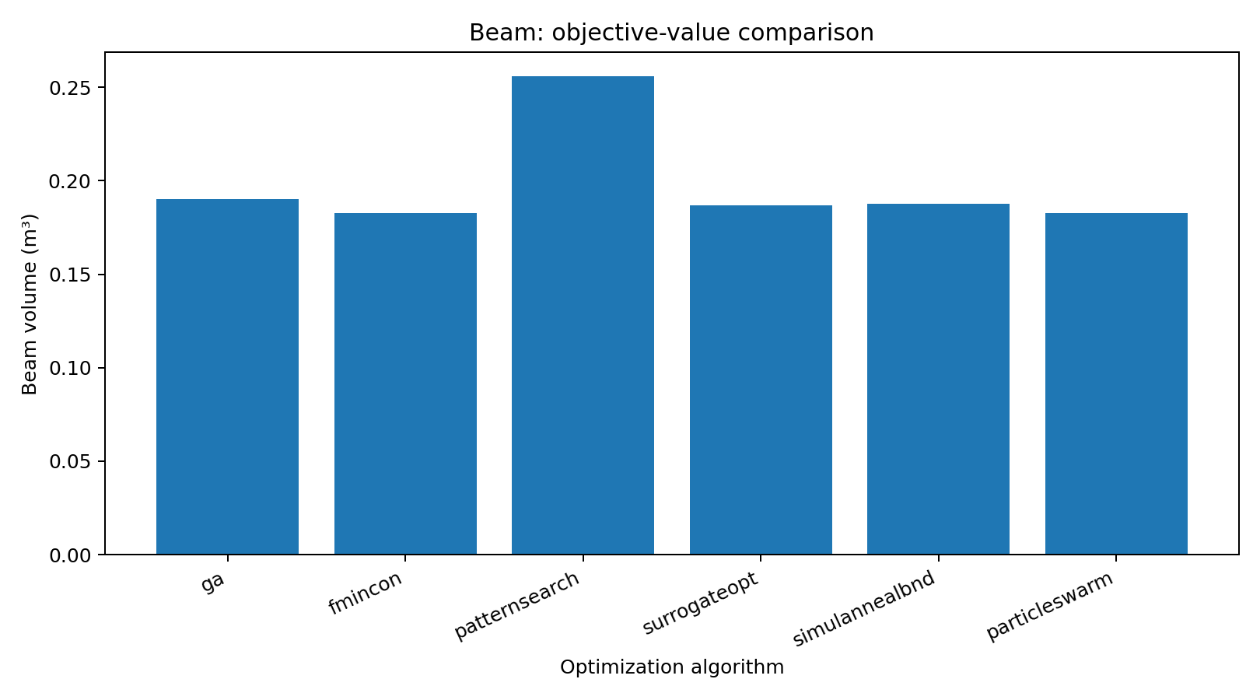

Question 3: Water tank
Algorithm | Median time (s) | Objective (m²) | Max constraint violation | Exit flag
ga | 0.0974761 | 119.265421 | 0 | 1
fmincon | 0.009541 | 119.265421 | 0 | 1
patternsearch | 0.0344816 | 119.265421 | 0 | 1
surrogateopt | 47.4469 | 119.265428 | 0 | 0
simulannealbnd | 0.119122 | 119.265421 | 0 | 0
particleswarm | 0.0216942 | 119.265421 | 0 | 1
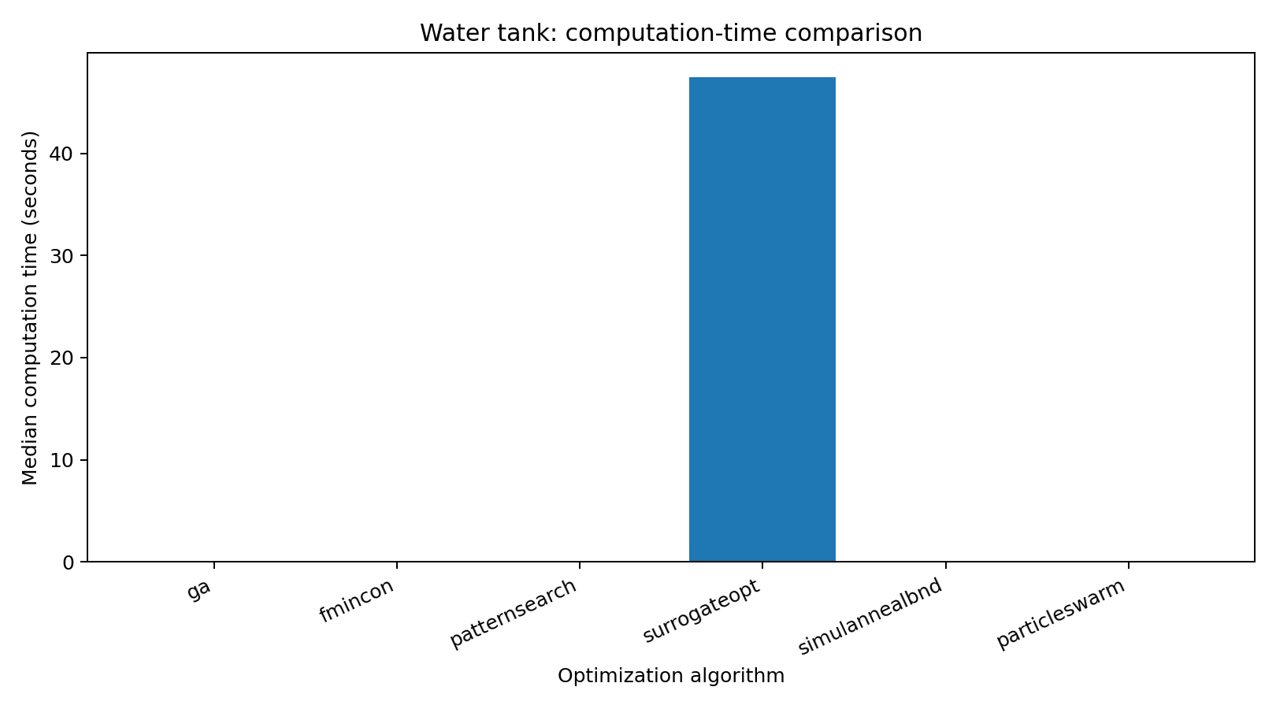
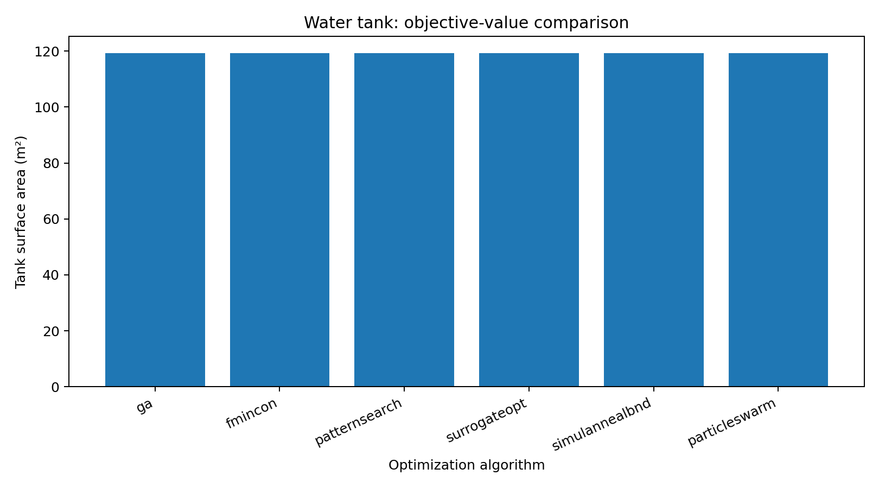

Overall computation-time comparison
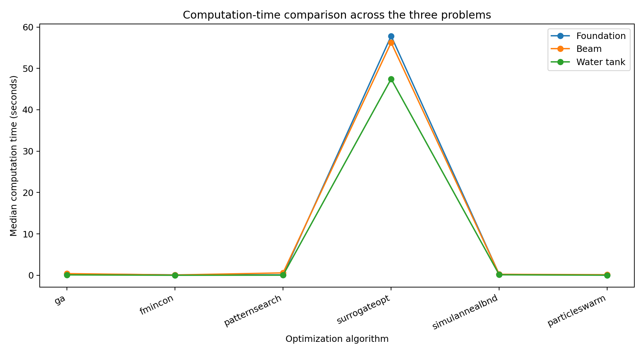

PART C: RESULTS, DISCUSSION AND CONCLUSION

1. Foundation problem
The reported concrete-volume objective values cluster around 5.0433 m³. Particle Swarm has the shortest reported median time (about 0.0507 s), while Surrogateopt takes the longest (about 57.83 s). The foundation results include small nonzero constraint violations, including the Particle Swarm result (about 5.04×10⁻⁴). These designs must be checked against the original bearing-pressure and settlement constraints before they are accepted as feasible.

2. Beam problem
Fmincon and Particle Swarm report the lowest beam volume, approximately 0.182855 m³. Fmincon is the fastest of the six methods in this run (about 0.0765 s). Surrogateopt is much slower (about 56.23 s). Fmincon and Particle Swarm have small nonzero constraint violations (approximately 9.42×10⁻⁶ and 9.14×10⁻⁶ respectively); Pattern Search also reports a small violation and a noticeably higher objective value. Verify the original stress and deflection constraints and solver output before selecting a final design.

3. Water-tank problem
All six algorithms report a surface area close to 119.26542 m², with zero reported constraint violation. Fmincon is the fastest (about 0.00954 s), while Surrogateopt is the slowest (about 47.45 s). The radius values are all close to 2.5154 m, consistent with the analytical optimum.

4. Comparison across algorithms
No single algorithm is fastest for every problem. Particle Swarm is fastest for the foundation run, while Fmincon is fastest for the beam and tank runs. Surrogateopt is slowest in all three cases. For solution selection, computation time alone is insufficient: the objective value, constraint violation and solver termination information must all be considered.

5. Important engineering and numerical checks
A small numerical constraint violation is still a violation unless it is within a justified engineering and solver tolerance. Re-evaluate every candidate design using the original unpenalized equations. For the foundation, calculate bearing pressure and settlement from the reported B and D. For the beam, calculate bending stress and deflection from the reported b and h. Confirm the tank capacity from πr²h = 100 m³. ExitFlag values should be interpreted using the relevant MATLAB solver documentation and output messages; do not treat an exit flag by itself as proof of engineering feasibility.
These are simplified educational optimization models. They do not constitute complete structural or geotechnical designs: factors such as reinforcement, punching shear, one-way shear, footing self-weight, detailed soil profiles, load combinations, beam shear, lateral stability, tank wall thickness, buckling, corrosion and construction requirements are not fully represented.

6. Conclusion
The six algorithms were applied to three distinct engineering optimization problems. Fmincon gave the shortest computation time for the beam and tank examples, and Particle Swarm was fastest for the foundation example. Surrogateopt required substantially longer computation times. The tank algorithms converged to essentially the same objective value. Final algorithm selection should be based on feasible designs and verified constraints as well as computational efficiency.

APPENDIX: MATLAB SOURCE FILES
The four MATLAB files are included in the accompanying ZIP package. For convenience, the source code is also included below.

Question1_Foundation.m
%% QUESTION 1: OPTIMIZATION OF AN ISOLATED RECTANGULAR FOOTING
% Find footing width B and thickness D that minimize concrete volume.
clear; clc; close all;

% Given data
P = 1800; % column load (kN)
qa = 200; % allowable bearing pressure (kN/m^2)
Es = 20000; % soil elastic modulus (kN/m^2)
nu = 0.30; % Poisson's ratio
If = 1.12; % simplified settlement influence factor
sAllow = 0.025; % allowable settlement (m)
rho = 1e4; % quadratic penalty coefficient

% Design variables x = [B,D]; footing length L = 1.2B
lb = [2.5 0.45];
ub = [5.0 0.80];
x0 = [3.5 0.55];

rawfun = @(x) 1.2*x(1)^2*x(2); % concrete volume (m^3)
violation = @(x) footingG(x,P,qa,Es,nu,If,sAllow);
fun = @(x) rawfun(x) + rho*sum(max(violation(x),0).^2);

problem.name = 'Foundation footing';
problem.fun = fun;
problem.rawfun = rawfun;
problem.violation = violation;
problem.lb = lb; problem.ub = ub; problem.x0 = x0;
problem.labels = {'B (m)','D (m)'};

Results = runSixSolvers(problem);

% Feasible design-space contour plot (B-D plane)
Bv = linspace(lb(1),ub(1),160);
Dv = linspace(lb(2),ub(2),160);
[BB,DD] = meshgrid(Bv,Dv);
Z = 1.2.*BB.^2.*DD;
G1 = P./(1.2.*BB.^2)./qa - 1;
q = P./(1.2.*BB.^2);
settlement = q.*BB.*(1-nu^2).*If./Es;
G2 = settlement./sAllow - 1;
feasible = (G1<=0) & (G2<=0);

figure('Color','w');
contourf(BB,DD,Z,20,'LineColor','none'); colorbar; hold on;
contour(BB,DD,double(feasible),[0.5 0.5],'k','LineWidth',2);
xlabel('Footing width B (m)'); ylabel('Footing thickness D (m)');
title('Foundation: concrete-volume contours and feasible boundary');
legend('Objective volume (m^3)','Feasible-region boundary','Location','best');
grid on;
exportgraphics(gcf,'Foundation_design_space.png','Resolution',300);

function g = footingG(x,P,qa,Es,nu,If,sAllow)
B=x(1);
q=P/(1.2*B^2);
s=q*B*(1-nu^2)*If/Es;
g=[q/qa-1; s/sAllow-1]; % feasible when each g <= 0
end

Question2_Beam.m
%% QUESTION 2: MINIMUM-VOLUME SIMPLY SUPPORTED RECTANGULAR BEAM
% Select width b and depth h to minimize beam material volume.
clear; clc; close all;

% Given data
P = 200; % central point load (kN)
L = 8; % span (m)
E = 200e6; % Young's modulus (kN/m^2), 200 GPa
sigmaAllow = 150e3; % allowable bending stress (kN/m^2), 150 MPa
deltaAllow = L/360; % allowable deflection (m)
rho = 1e4; % quadratic penalty coefficient

% Design variables x = [b,h]
lb = [0.03 0.25];
ub = [0.15 0.70];
x0 = [0.08 0.50];

rawfun = @(x) L*x(1)*x(2); % beam volume (m^3)
violation = @(x) beamG(x,P,L,E,sigmaAllow,deltaAllow);
fun = @(x) rawfun(x) + rho*sum(max(violation(x),0).^2);

problem.name = 'Simply supported beam';
problem.fun = fun;
problem.rawfun = rawfun;
problem.violation = violation;
problem.lb = lb; problem.ub = ub; problem.x0 = x0;
problem.labels = {'b (m)','h (m)'};

Results = runSixSolvers(problem);

% Feasible design-space contour plot
bv = linspace(lb(1),ub(1),160);
hv = linspace(lb(2),ub(2),160);
[BB,HH] = meshgrid(bv,hv);
Z = L.*BB.*HH;
M = P*L/4;
sigma = 6*M./(BB.*HH.^2);
I = BB.*HH.^3/12;
delta = P*L^3./(48*E.*I);
feasible = (sigma<=sigmaAllow) & (delta<=deltaAllow);

figure('Color','w');
contourf(BB,HH,Z,20,'LineColor','none'); colorbar; hold on;
contour(BB,HH,double(feasible),[0.5 0.5],'k','LineWidth',2);
xlabel('Beam width b (m)'); ylabel('Beam depth h (m)');
title('Beam: material-volume contours and feasible boundary');
legend('Objective volume (m^3)','Feasible-region boundary','Location','best');
grid on;
exportgraphics(gcf,'Beam_design_space.png','Resolution',300);

function g = beamG(x,P,L,E,sigmaAllow,deltaAllow)
b=x(1); h=x(2);
M=P*L/4;
I=b*h^3/12;
sigma=6*M/(b*h^2);
delta=P*L^3/(48*E*I);
g=[sigma/sigmaAllow-1; delta/deltaAllow-1]; % feasible when g <= 0
end

Question3_WaterTank.m
%% QUESTION 3: MINIMUM-SURFACE-AREA CLOSED CYLINDRICAL WATER TANK
% Find tank radius r and height h for a fixed capacity of 100 m^3.
% Eliminate h using the volume equality, so all solvers optimize r only.
clear; clc; close all;

V = 100; % required capacity (m^3)
rMin = 2.0; rMax = 4.0;
hMin = 2.0; hMax = 10.0;

% h = V/(pi*r^2); derive radius bounds that also satisfy height bounds
lb = max(rMin,sqrt(V/(pi*hMax)));
ub = min(rMax,sqrt(V/(pi*hMin)));
x0 = 2.8;
rawfun = @(x) tankArea(x,V);

problem.name = 'Closed cylindrical water tank';
problem.fun = rawfun;
problem.rawfun = rawfun;
problem.violation = @(x) [];
problem.lb = lb; problem.ub = ub; problem.x0 = x0;
problem.labels = {'r (m)'};

Results = runSixSolvers(problem);

% Recover dimensions for each algorithm and print them
fprintf('\nTank dimensions from each solver:\n');
for k=1:height(Results)
r = Results.X{k}(1);
h = V/(pi*r^2);
fprintf('%s: r = %.5f m, h = %.5f m, area = %.5f m^2\n', ...
Results.Algorithm(k),r,h,Results.ObjectiveValue(k));
end

% Plot reduced objective function versus radius
rv = linspace(lb,ub,300);
Av = arrayfun(@(r) tankArea(r,V),rv);
figure('Color','w');
plot(rv,Av,'LineWidth',2);
xlabel('Tank radius r (m)'); ylabel('Closed-tank surface area (m^2)');
title('Water tank: surface area versus tank radius');
grid on;
exportgraphics(gcf,'WaterTank_design_curve.png','Resolution',300);

function A = tankArea(x,V)
r=x(1);
h=V/(pi*r^2);
A=2*pi*r*h+2*pi*r^2; % curved side plus top and bottom
end

runSixSolvers.m
function Results = runSixSolvers(problem)
% RUNSIXSOLVERS Compare six MATLAB optimization algorithms on one problem.
% problem fields:
% name, fun (penalized objective), rawfun (engineering objective),
% violation (returns g(x)<=0), lb, ub, x0, labels
%
% Required toolboxes:
% Optimization Toolbox: fmincon
% Global Optimization Toolbox: ga, patternsearch, surrogateopt,
% simulannealbnd, particleswarm

solvers = {'ga','fmincon','patternsearch','surrogateopt', ...
'simulannealbnd','particleswarm'};
nRepeat = 3;
nSolver = numel(solvers);
times = nan(nSolver,1);
fvals = nan(nSolver,1);
violations = nan(nSolver,1);
solutions = cell(nSolver,1);
exitflags = nan(nSolver,1);

for k = 1:nSolver
runTimes = nan(nRepeat,1);
runX = cell(nRepeat,1);
runF = nan(nRepeat,1);
runV = nan(nRepeat,1);
runExit = nan(nRepeat,1);

for rep = 1:nRepeat
rng(100*k + rep,'twister');
n = numel(problem.lb);
lb = problem.lb(:)';
ub = problem.ub(:)';
x0 = problem.x0(:)';
objective = problem.fun;

t0 = tic;
switch solvers{k}
case 'ga'
opts = optimoptions('ga','Display','off', ...
'PopulationSize',40,'MaxGenerations',80);
[x,~,ef] = ga(objective,n,[],[],[],[],lb,ub,[],opts);

case 'fmincon'
opts = optimoptions('fmincon','Display','off', ...
'Algorithm','sqp','MaxIterations',500, ...
'MaxFunctionEvaluations',5000);
[x,~,ef] = fmincon(objective,x0,[],[],[],[],lb,ub,[],opts);

case 'patternsearch'
opts = optimoptions('patternsearch','Display','off', ...
'MaxIterations',500,'MaxFunctionEvaluations',5000);
[x,~,ef] = patternsearch(objective,x0,[],[],[],[],lb,ub,[],opts);

case 'surrogateopt'
opts = optimoptions('surrogateopt','Display','off', ...
'MaxFunctionEvaluations',250);
[x,~,ef] = surrogateopt(objective,lb,ub,[],[],[],[],[],opts);

case 'simulannealbnd'
opts = optimoptions('simulannealbnd','Display','off', ...
'MaxIterations',500,'MaxFunctionEvaluations',5000);
[x,~,ef] = simulannealbnd(objective,x0,lb,ub,opts);

case 'particleswarm'
opts = optimoptions('particleswarm','Display','off', ...
'SwarmSize',40,'MaxIterations',100);
[x,~,ef] = particleswarm(objective,n,lb,ub,opts);
end
runTimes(rep) = toc(t0);
x = x(:)';
runX{rep} = x;
runF(rep) = problem.rawfun(x);
g = problem.violation(x);
if isempty(g)
runV(rep) = 0;
else
runV(rep) = max([0; g(:)]);
end
runExit(rep) = ef;
end

% Choose the lowest-objective feasible result. If no repeat is
% feasible, report the least-violating candidate and flag it.
feasible = find(runV <= 1e-5);
if ~isempty(feasible)
[~,j] = min(runF(feasible));
chosen = feasible(j);
else
[~,chosen] = min(runV);
warning('%s did not find a feasible result for %s.',solvers{k},problem.name);
end

times(k) = median(runTimes);
fvals(k) = runF(chosen);
violations(k) = runV(chosen);
solutions{k} = runX{chosen};
exitflags(k) = runExit(chosen);
end

Algorithm = string(solvers(:));
MedianTime_s = times;
ObjectiveValue = fvals;
MaxConstraintViolation = violations;
ExitFlag = exitflags;
X = solutions;
Results = table(Algorithm,MedianTime_s,ObjectiveValue, ...
MaxConstraintViolation,ExitFlag,X);
disp("Results for " + problem.name);
disp(Results);

safeName = regexprep(problem.name,'[^A-Za-z0-9]','_');
writetable(Results,[safeName '_results.csv']);

figure('Color','w');
bar(categorical(Algorithm),MedianTime_s);
ylabel('Median elapsed time (seconds)');
xlabel('Optimization algorithm');
title([problem.name ': computation-time comparison']);
grid on;
exportgraphics(gcf,[safeName '_time_comparison.png'],'Resolution',300);

figure('Color','w');
bar(categorical(Algorithm),ObjectiveValue);
ylabel('Best feasible objective value');
xlabel('Optimization algorithm');
title([problem.name ': objective-value comparison']);
grid on;
exportgraphics(gcf,[safeName '_objective_comparison.png'],'Resolution',300);

save([safeName '_results.mat'],'Results','problem');
end

